Escola: Data:
Aluno: Turma:

Recorte e cole cada relógio no local que mostra o seu horário

IT’S A QUARTER TO NINE | IT’S TWO O’CLOCK | IT’S MIDNIGHT
IT’S SEVEN O’CLOCK | IT’S MIDDAY | IT’S HALF PAST THREE
 | 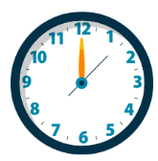 | 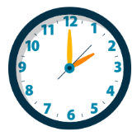
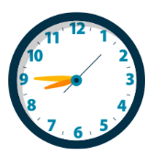 | 