Circule o nome correto da fruta

 | Pear Apple Banana
 | Orange Grape Watermelon
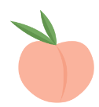 | Melon Peach Passion fruit
 | Avocado Strawberry Apple
 | Grape Pear Melon
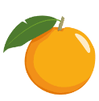 | Orange Apple Peach

