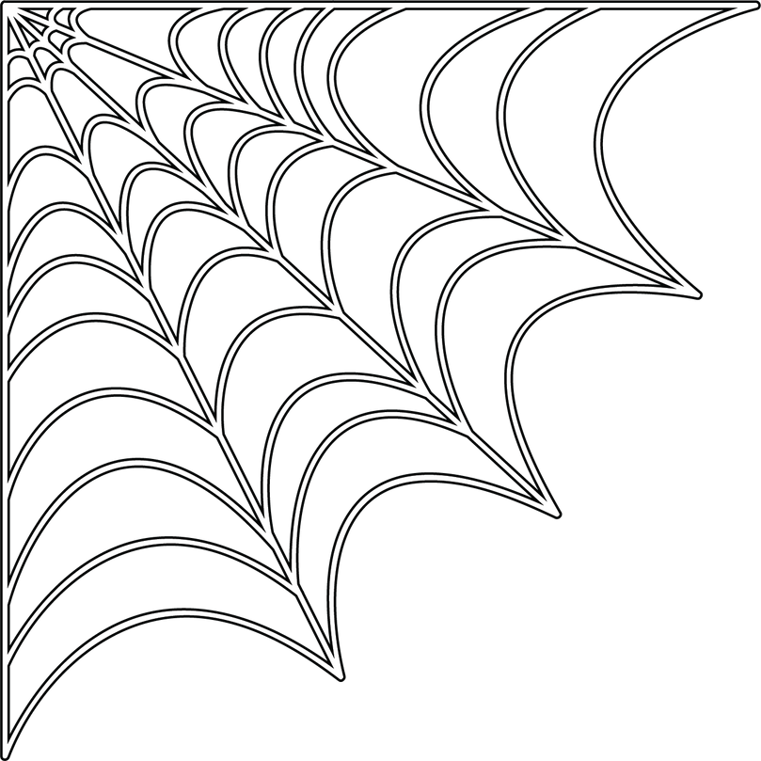**Escola: Data: Aluno: Turma:**

**CAÇA-PALAVRAS**

|  |  |  |  |  |  |  |  |  |  |  |  |  |  |  |  |  |  |  |  |
| --- | --- | --- | --- | --- | --- | --- | --- | --- | --- | --- | --- | --- | --- | --- | --- | --- | --- | --- | --- |
| A | S | X | E | R | A | T | T | S | P | I | D | E | R | Y | U | Z | T | R | I |
| C | L | C | X | H | Y | F | U | Y | B | R | L | R | T | Y | H | B | T | E | W |
| F | W | M | B | A | T | D | I | J | A | B | M | I | D | Ç | I | O | P | Ç | A |
| V | D | Z | T | L | B | F | Y | D | Z | C | O | S | T | U | M | E | P | B | T |
| A | Y | C | Y | L | N | U | A | S | X | E | R | A | T | O | T | T | O | I | G |
| T | B | T | U | O | M | I | Z | O | M | B | I | E | D | O | P | J | A | P | L |
| D | U | I | L | W | O | F | R | N | L | G | R | R | P | S | U | I | C | J | Q |
| I | P | A | J | E | B | E | S | C | A | D | S | C | A | N | D | Y | Z | D | A |
| Q | T | E | T | E | O | W | P | Ç | D | A | R | D | P | P | J | A | Z | w | D |
| A | D | W | H | N | Ç | B | J | N | P | I | E | R | C | E | R | P | F | W | F |
| P | P | I | A | U | E | I | C | I | G | U | W | D | I | C | S | E | Y | A | T |
| C | D | E | Y | L | R | T | Z | F | R | L | L | P | D | U | E | W | N | K | Y |
| V | A | M | P | I | R | E | E | F | K | B | M | P | Ç | Y | J | B | Y | K | U |
| D | V | O | J | D | U | O | F | O | T | P | U | M | P | K | I | N | W | W | H |
| A | S | X | E | R | A | T | T | C | F | L | Ç | R | T | U | P | D | L | U | X |
| B | P | B | J | A | U | C | Z | K | M | B | I | E | D | L | P | M | K | O | Z |

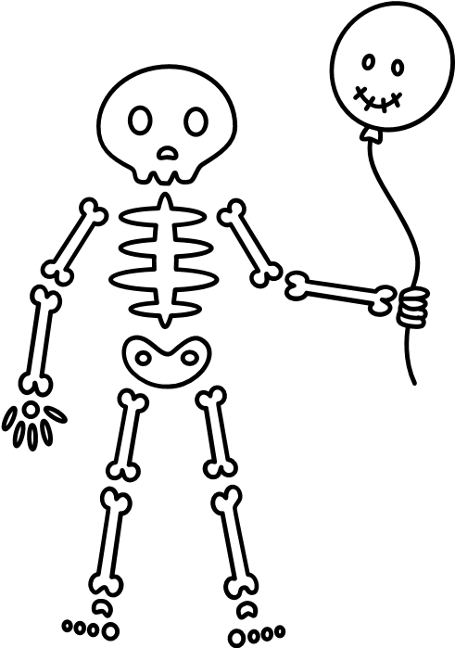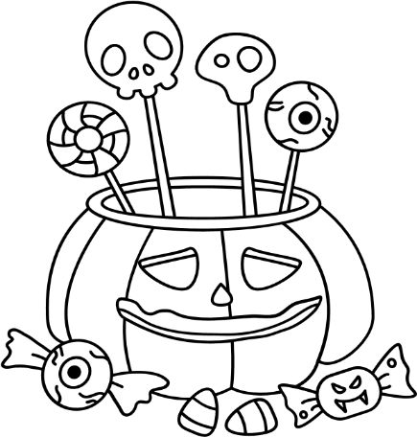

**Halloween**

**Candy**

**Zombie**

**Costume**

**Vampire**

**Coffin**

**Pumpkin**

**Spider**

**Bat**